REQUEST FOR REPORT RELATED TO
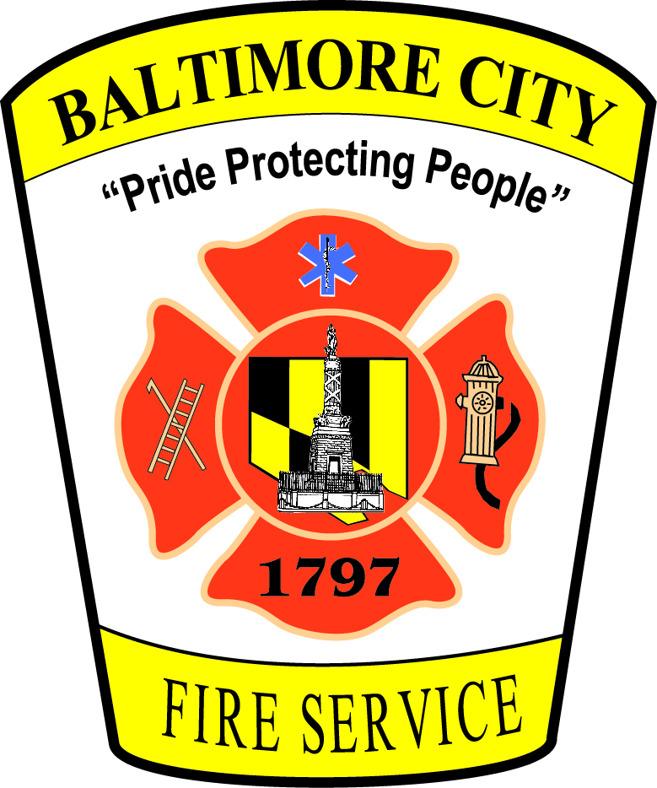
FIRE OR CARBON MONOXIDE INCIDENT

Requestor’s Information:
Name: Click here to enter text.
E-mail Address: Click here to enter text.
Mailing Address: Click here to enter text.
Phone Number: Click here to enter text.

Information Request:
In order to expedite your request, please provide as much of the following information as possible regarding the record that you are seeking:
Type of Report (Please indicate by marking the appropriate box):
☐ Fire Investigation Report
☐ Fire Incident Report (otherwise known as Fire Run Report)
☐ Carbon Monoxide Investigation Report
☐ Other - Click here to enter text.

Address/Location of Incident: Click here to enter text.

Date of Incident: Click here to enter text.

Approximate Time of Incident: Click here to enter text.

Additional Relevant Information: Click here to enter text.

____________________________________________________________________________________
Please note - for requests made under the Maryland Public Information Act, the Baltimore City Fire Department is required to redact medical or psychological information, except if the record is requested by a person in interest, yourself, or a person you have the legal authority to represent. See Md. Ann. Code, General Provisions Art., § 4-329.

Please return this form to: Amy Beth Leasure, Chief of Legal and Regulatory Affairs
BCFDMPIA@Baltimorecity.gov
401 E. Fayette Street, Mezzanine Level
Baltimore, MD 21202

