REQUEST FOR EMERGENCY MEDICAL SERVICES (EMS) REPORT
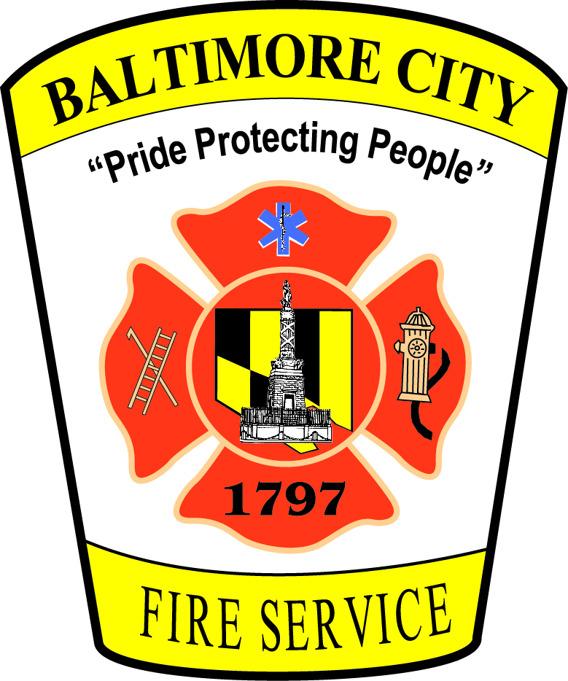
OR PATIENT CARE REPORT

Requestor’s Information:
Name: Click here to enter text.
E-mail Address: Click here to enter text.
Mailing Address: Click here to enter text.
Phone Number: Click here to enter text.

Information Request:
In order to expedite your request for an EMS or Patient Care Report, please provide as much of the following information as possible regarding the record you are seeking:
Name of Patient: Click here to enter text.

Date of Birth of Patient: Click here to enter text.

Date of Incident: Click here to enter text.

Approximate Time of Incident: Click here to enter text.

Address/Location of Response: Click here to enter text.

Additional Relevant Information: Click here to enter text.

____________________________________________________________________________
Please note, for requests made under the Maryland Public Information Act, the Baltimore City Fire Department is required to redact medical or psychological information, except if the record is requested by a person in interest, yourself, or a person you have the legal authority to represent. See Md. Ann. Code, General Provisions Art., § 4-329.

Please return this form to: Amy Beth Leasure, Chief of Legal and Regulatory Affairs
BCFDMPIA@Baltimorecity.gov
401 E. Fayette Street, Mezzanine Level, Baltimore, MD 21202

